Fundamentals of Software Engineering
Project Deliverable 3: System Decomposition, Architecture, and Plan
Due Date:25-May-2022 Group Name: Group 7
Group Members: Aun Ali ,Ammar Ahmed, Aroob Khalid, Hassan bin Zaid, Muhammad Noor Malik
The “Call and Return” Architecture has been adopted for the ARS(Airline Reservation System), due to its simplicity in managing submodules, each module calls its submodule for confirmation and the process then continues.
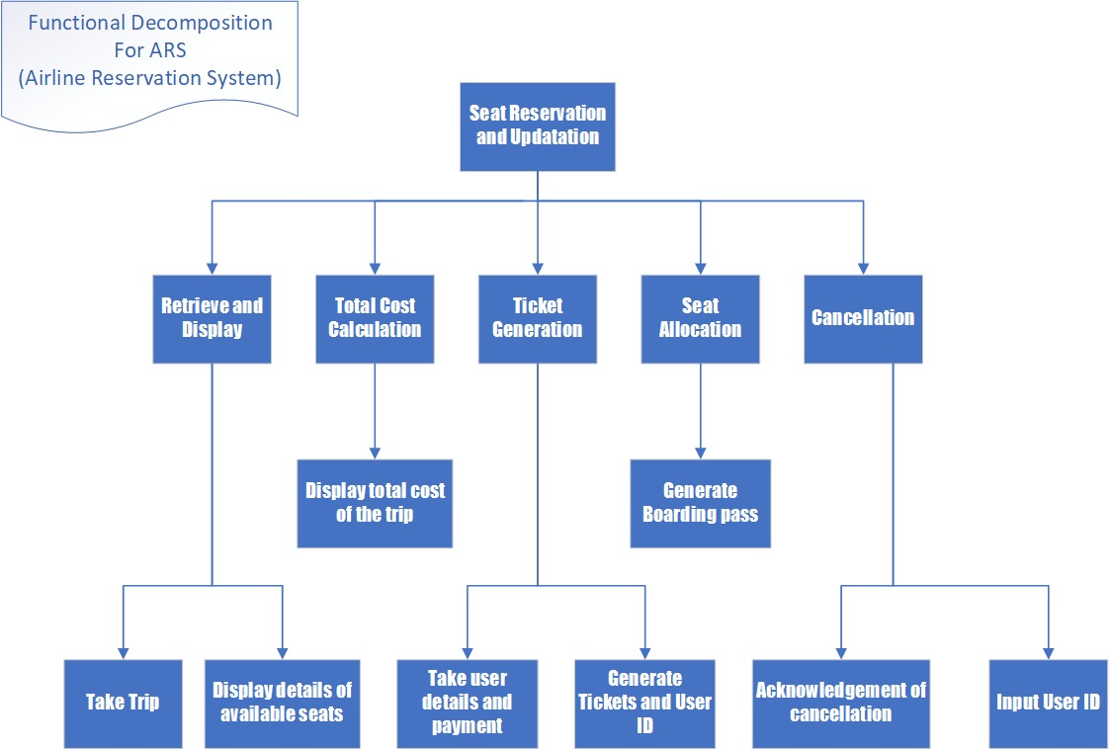
Functional decomposition is used to decompose / divide steps into subfunctions and smaller parts which help break down the overall process.
The diagram is shown in a top-down format illustrating a process. A functional decomposition diagram contains the overall function or task as well as the necessary sub-functions or tasks needed to achieve the overall objective.

The following Gantt Chart provides the expected timeline of the project
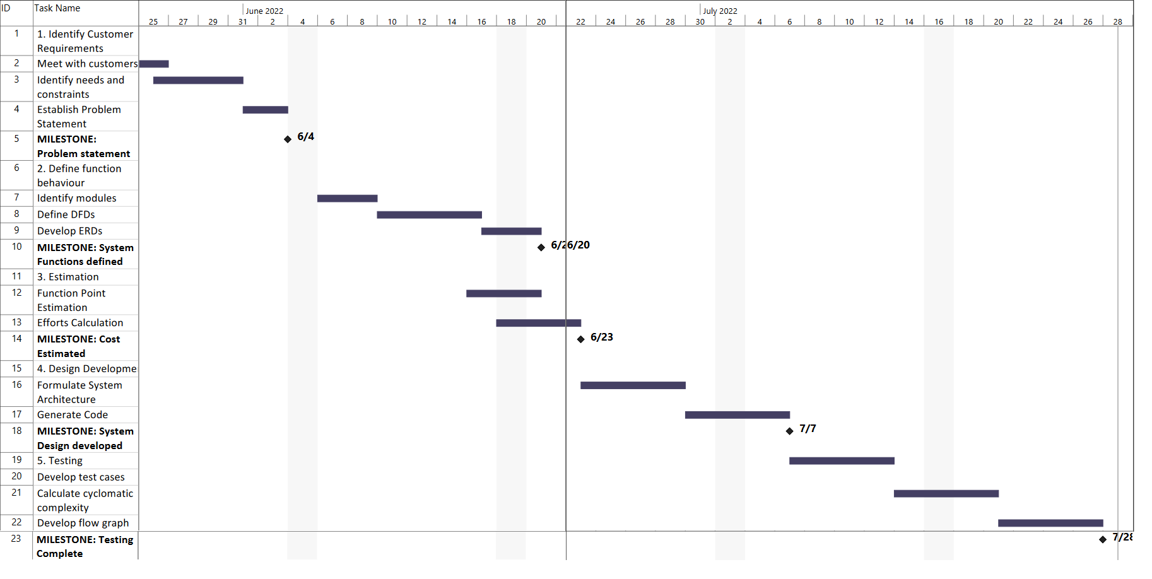
Activity / Work Item /Task | Assigned to | Performed by | Remarks
Interface and Problem Statement | Aun Ali - 20L-1300 | Aun Ali – 20L-1300 | Aun Ali had a little bit knowledge of wordpress
Gantt Chart | Ammar Ahmed– 20L-0961 | Ammar -20L-0961 | Ammar new how to make Gantt Chart on MS Project
SRS | Aroob Khalid – 20L-1313  Hassan bin Zaid – 20L-1365 | Aroob Khalid – 20L-1313  Hassan bin Zaid – 20L-1365
Architecture | Muhammad Noor Malik – 20L-1349 | Muhammad Noor Malik – 20L-1349
The approximate completion time is 10 weeks in this project.

